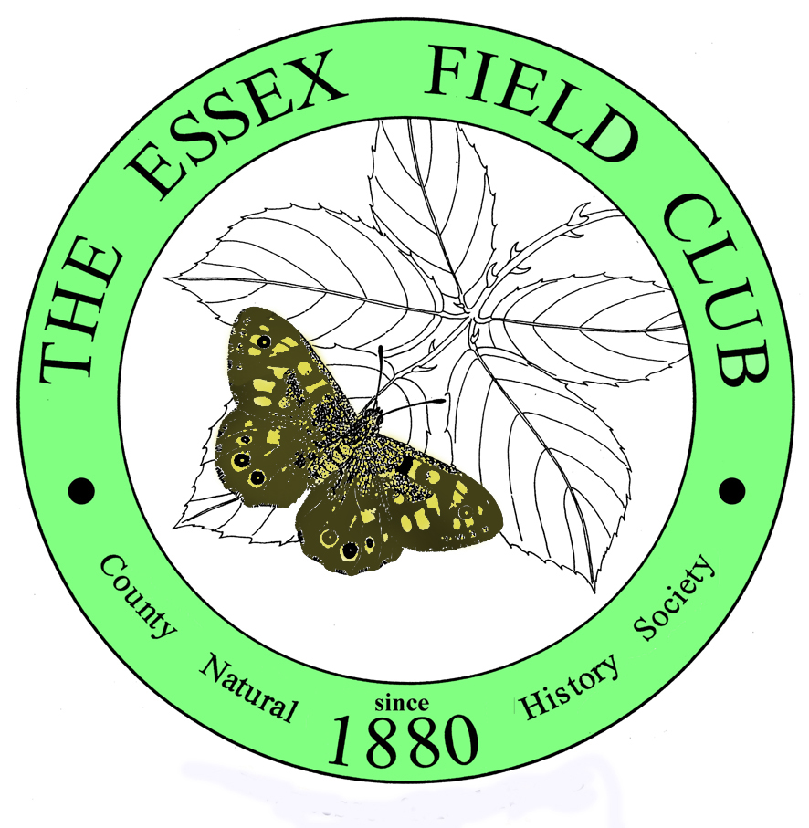 | ESSEX FIELD CLUB  www.essexfieldclub.org.uk
Dr Ken Adams
63, Wroths Path, Baldwins Hill,
020 8508 7863 Loughton
ken.adams@virgin.net Essex IG10 1SH

Invitation to Essex Field Club’s Exhibition and Social meeting, Saturday 7th December 2013

The Essex Field Club holds an Exhibition and Social meeting each year. It is primarily a varied collection of exhibits displaying all aspects of the natural history of Essex. Some of our own members bring items relating to their recent work, but we also welcome other organisations or individuals to bring something to show their work and activities in the outdoor environment. This year you may bring a memory stick with a presentation
to be shown on a digital projector (10 minutes max, please). We invite your organisation to be represented this year, and in doing so bring your work to the attention of over one hundred local naturalists that attend every year.

The meeting this year is on Saturday 7th December, in the Green Centre, Wat Tyler Country Park, Basildon, SS16 4UH, from 2:30 to 5pm. If you need help to locate the venue, please ask me or getamap.co.uk or look on our website www.essexfieldclub.org.uk. The grid ref is TQ738865, by Pitsea Hall Lane. Exhibitors are welcome to set up from 1:30 and must be cleared away by 5:30pm. There will be semi-circular tables set up, with area a bit less than a standard trestle table, and also there will be space for your own free-standing displays if required. Refreshments will be available. If your organisation has items for sale, please bring some, and/or leaflets etc.

Please let us know by Friday 22nd November, either by email or by returning the slip below, using the contact details above. Please remember to include a title for the exhibit/display, which will be given to visitors as part of the programme on arrival, and attach a summary of what your exhibit/display will be about, for our records.

Even if you feel your organisation cannot contribute an exhibit, we would like to extend an invitation to attend to all of your members or associates; there is no admission charge.

We look forward to hearing from you. Yours sincerely, Mary Smith (on behalf of Ken Adams)
----------------------------------------------------------------------------------------------------------------------
Please book me a table with: (Yes/No)
Access to electric socket? …… A vertical surface (against a wall)………
Floor space?(number of feet/metres)……….. A display board on top of table (few available)?.........
Title of exhibit:...........................................................................................................................................
....................................................................................................................................................................

Your name / your organisation’s name…………………………………………...................…………....

Address……………………………………………………………………………………………….......
E mail……………………………………………………. phone number………………………….......

PLEASE SCROLL DOWN TO SEE OUR POSTER

