Kent Heritage Tree Project Photography courses
at Bedgebury Pinetum 2nd November 2013
With Edward Parker
Close up Autumn Photography 9.30 -12.30
Autumn Tree and Landscape Photography 1.30-4.30
A three hour introduction to macro and close-up photography and/or autumn tree and landscape photography based at Bedegebury Pinetum with professional photographer Edward Parker which is suitable for photographers of all levels of experience whether using compacts, bridge cameras or DSLRs. The course is based on Edward’s extensive experience of photographing plants and wildlife both here and abroad for organisations such as WWF, The Tropical Forest Trust, The Eden Project and Kew Gardens. Edward will offer expert tuition on how to get the very best results from whatever equipment you are using – for example compacts are often equally as good as DSLRs for macro photography. He will also instruct you on how to take advantage of the weather conditions whether it’s overcast and raining or brilliant sunshine. So don’t worry too much about the weather.
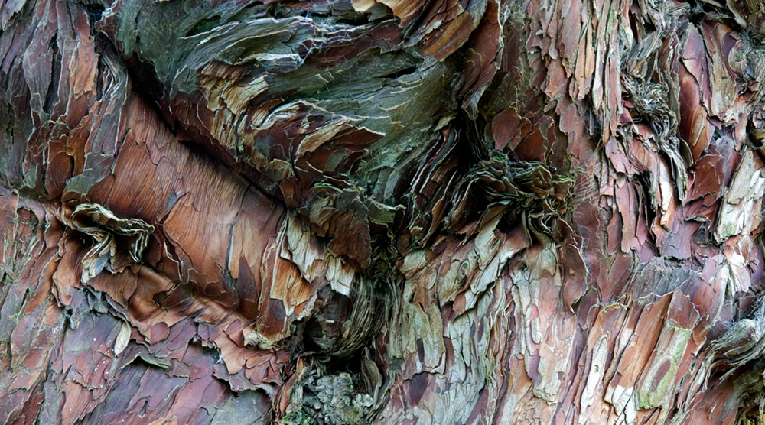
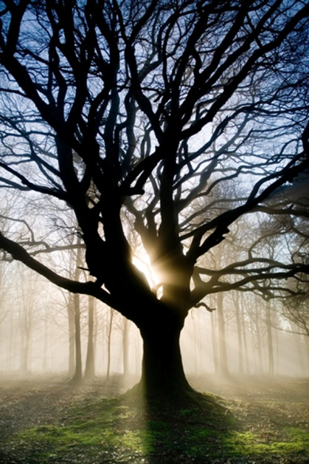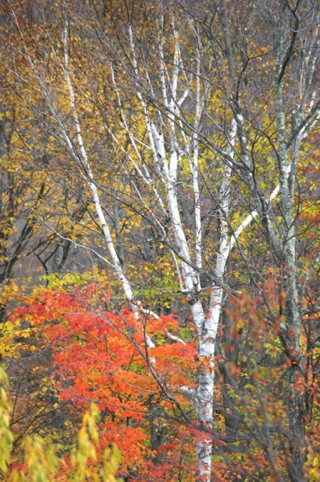

Suitable for people of all abilities and all types of cameras.
£35 per workshop (please pay by cash on the day)
Event Location: Walled Garden at Bedgebury Pinetum

Autumn Close-Up Course 9.30 – 12.30

The great thing about photographing flowers, leaves and other close-up objects is that you don’t need to travel far to get good photos. It is just as possible to get stunning images in your front room or in a local park as it is in some tropical forest if you know how. And it is possible to get good images with almost any sort of camera. In fact compact and bridge cameras can come into their own because they can often get very close to subjects without needing any specialist equipment.

During the course we will look at the capabilities of your camera (often much better than you would think) and how to set it up to take the very highest quality images. We will also look at the benefits/limitations of using the auto settings and then how to take more control of the camera to improve the results. We will also look at the advantages of macro lenses and flash guns for those using DSLR or CCS.

At Bedgebury there will be opportunities to photograph bark, leaves, rare pine trees, cones, needles, mushrooms etc. in glorious surroundings.

Autumn Tree and Landscape Course 1.30 – 4.30

Bedgebury Pinetum is a superb setting for learning about tree and landscape photography. The wide variety of trees, the undulating grounds and the various lakes provides an ideal location to learn about composition, the use of foreground, background and lighting, all of which are equally relevant to photographers of all abilities and regardless of the type of camera they use.

During the course we will look at the capabilities of your camera (often much better than you would think) and how to set it up to take the very highest quality images. We will also look at the benefits/limitations of using the auto settings and then how to take more control of the camera) to improve the results.

Advice

It is advised to bring comfortable walking boots and warm clothing in case it is cold. Also, it is useful to fully charge the camera batteries the night before, bring sufficient memory card space and, if possible, bring along the instruction booklet too.

How to Find Us

Sat Navs Use: Lady Oak Lane, Goudhurst TN17 2

From Ashford

- Head southwest on Station Rd/A2042 toward Dover Pl, Continue to follow A2042
- Turn right onto Victoria Rd
- Take the 3rd left onto Victoria Way
- Continue straight onto Leacon Rd, go through 1 roundabout
- Turn right onto Brookfield Rd/B2229
- At the roundabout, take the 1st exit onto A28. Go through 1 roundabout
- Turn right onto Biddenden Rd/A262, continue to follow A262
- Keep right to continue on Tenterden Rd/A262
- Turn right to stay on Tenterden Rd/A262
- Turn left onto High St/A262, Continue to follow A262
- At the roundabout, take the 2nd exit onto Goudhurst Rd/A262, Continue to follow A262
- Turn left onto Maypole Ln
- Keep left to stay on Maypole Ln
- Continue onto Bedgebury Rd/B2079. Continue to follow B2079 destination will be on the left.

From Maidstone

- Head north on College Rd/A229 toward Knightrider St/A249. Continue to follow A229
- Slight right onto Mill St
- Turn right onto Palace Ave/A229. Continue to follow A229
- Turn right onto Loose Rd/A229. Continue to follow A229
- Slight right onto Maidstone Rd/B2079. Continue to follow B2079
- Turn right onto High St/B2079. Continue to follow B2079
- Turn right onto Bedgebury Rd/B2079. Continue to follow B2079, destination will be on the left

From Tunbridge Wells

- Head east on Crescent Rd/A264 toward Mt Pleasant Ave. Continue to follow A264, go through 1 roundabout
- Turn left onto Pembury Rd/A264. Go through 1 roundabout
- At the roundabout, take the 1st exit onto the A21 ramp to Hastings/Lamberhurst
- Merge onto Hastings Rd/A21, continue to follow A21. Go through 4 roundabouts
- Turn left onto B2079, destination will be on the right

